yana
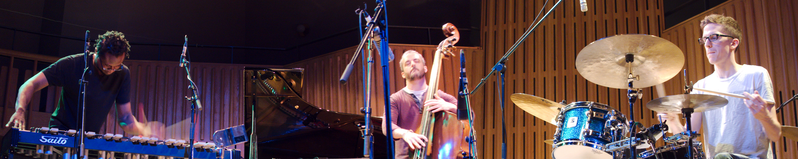
yana creates an open, living music.
They got together in Stratford-upon-Avon on a dark and stormy night in November 2008, and from there have undertaken two national tours; performed at Manchester Jazz Festival; and supported US jazz saxophone legend David Murray.
The music is a free-wheeling, spontaneous mixture of styles. This trio has developed a process entirely focussed on creating highly expressive live music that's full of grooves and sounds composed, but is not; and playing compositions that don't sound composed at all, but are.
How it all works is not always clear; but the process is always fascinating to hear, and the results can be truly moving.
Their newest studio recording is called don't overthink it, which has garnered favourable attention in Jazzwise, on All About Jazz and in a critics' chart on The Wire's website.
Download a free track:
soundcloud.com/cmdkjb/rundown
See all our releases:
cm-dk-jb.bandcamp.com

Biographies
Dave Kane plays bass. He plays with pianist Matthew Bourne and Stephen Davis, and the hip-hop artist Napoleon Maddox and has a fantastic duo with the trumpeter Alex Bonney which performed with Ken Vandermark in 2008. Dave is also founder of a creative musicians' collective in Leeds called LIMA.
Joshua Blackmore is on drums. He's in Curios with Tom Cawley and Sam Burgess, Troyka with Kit Downes and Chris Montague, and has worked with Django Bates, Aloosh and the Floating Points Ensemble.
Corey Mwamba plays the vibraphone. As well as having made four electro-acoustic albums, Corey is on two albums made by Quantic, three by Nat Birchall, one by Arun Ghosh and one by Ty. He's worked with lots of people including Mat Maneri and Lucian Ban, The Heliocentrics, Orphy Robinson, Robert Mitchell, Andy Hamilton, Scanner and Tony Kofi.

Quotes
This is the sound of three minds working together in a utopian zone, way beyond the individual ego – and producing something quite beautiful in the process.
Jazzwise Magazine
The intuitive understanding shared by all three musicians is paramount in creating this very attractive musical world. Engaging and evocative music.
All About Jazz
They sustained that beguiling sense of music that is being conjured before your eyes, and ears, that only the best group playing evokes – fans of the Wayne Shorter Quartet will know what I mean.
Bristol Jazz Log

Information and bookings
Please contact Corey Mwamba on (+44)7582 830798 or e-mail trio@coreymwamba.co.uk; alternatively, visit yana.coreymwamba.co.uk

